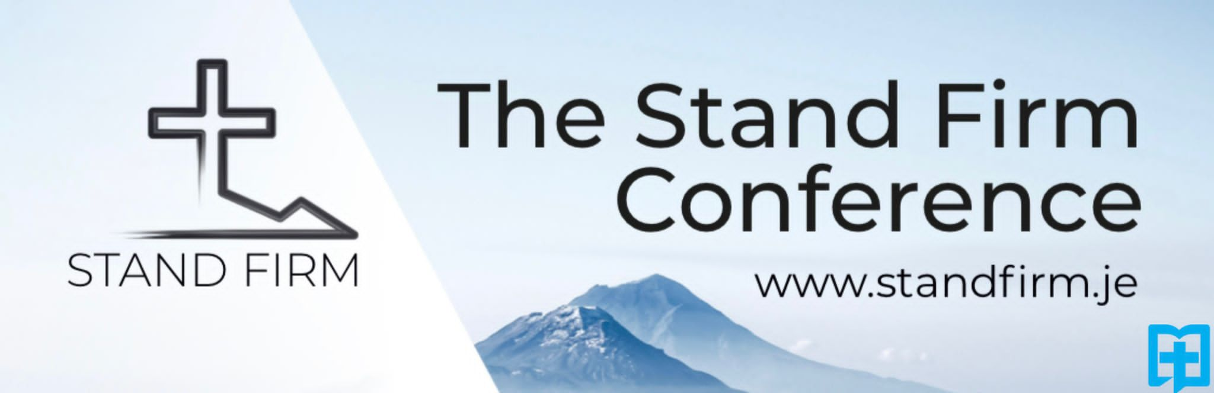
Welcome!
We are delighted to have you join us for the Stand Firm conference!
The Stand Firm conference aims to encourage the church to:
- Live worthily of the Gospel

- Present a biblical world view

- Faithfully preach the whole counsel of God
We hope you leave the conference encouraged to stand firm for Christ wherever He has placed you.
Programme
Saturday (October 22nd)
- 1:00PM Registration and coffee
- 2:00PM Session 1 – Leon Coates on “Standing Firm in the Unity of the Gospel”
- 3:30PM Coffee
- 4:00PM Session 2 – Albert Solano on “Standing Firm in a Troubled World”
- 5:30PM End
Sunday (October 23rd)
- 09:30AM Coffee
- 10:00AM Session 3 – Dr. John Glass on “Standing Firm: How Calvin Stood Firm”
- 11:30AM Coffee
- 12:00PM Session 4 – Drew Waller on “Standing Firm in Your Salvation and Prayer”
- 13:30PM Lunch
- 15:00PM Session 5 – Leon Coates on “Standing Firm: Instructions to an Infiltrated Church”
- 16:30PM End
Help
Should you need assistance during the conference please go to the registration desk by the front door. If you have follow-up questions after the conference please email contact@quennevaisec.com.
Finally, please complete the feedback form on the next page…

Attendee Feedback
Should we do the Stand Firm conference again?

Why?

What was good about the Stand Firm conference?

What was bad about the Stand Firm conference?

If we were to do the Stand firm conference again what would you find helpful?

To receive news about the Stand Firm conference in future please leave your email address:

